Manila Water Company
Customer NameDocument Title

FUNCTIONAL SPECIFICATION – INTERFACE

DID_M2C_138

Inbound Dunning Activity Interface

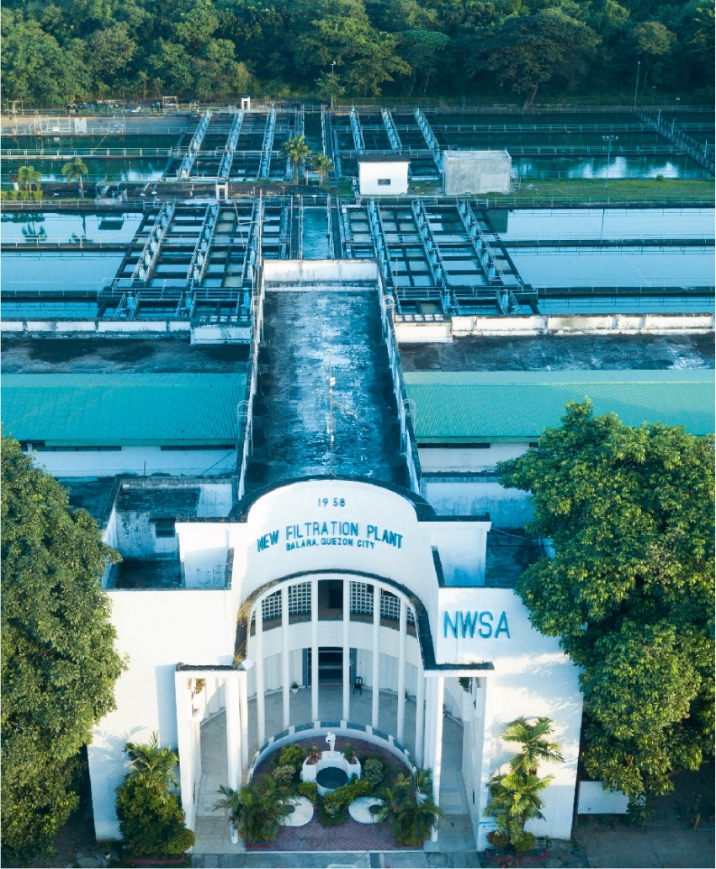




Contents
1 Document Organization 4
1.1 Document Log 4
1.2 Integration, Document Reference 4
2 Functional Description 4
2.1 Functional Flow Diagram of the Business Process 5
2.2 Authorization Requirements 5
2.3 Dependencies / Constraints 5
2.4 Assumptions 5
2.5 Security Requirements 6
2.6 System Details & Direction 6
2.7 Transaction Volume 6
2.8 Frequency & Timing 6
2.9 Initiating Process / Transaction / Program 7
2.10 Processing Type 7
3 Detailed description 7
3.1 Functional Requirement 7
3.2 Interface Process Flow Diagram 12
3.3 Proposed Transfer Method / Program 13
3.4 File Specifics 13
3.5 Validation of Selection Criteria 14
3.6 Variants 14
3.7 Target / Source Data Layout 14
3.8 Mapping SAP Fields to Source / Target 14
3.9 Transaction Screen Sequence 15
3.10 Dependencies 15
3.11 Post Interface Activities 15
3.12 Source Data Archiving Requirements 15
3.13 Network Integration 15
3.14 Reporting 16
3.15 Error Handling 16
3.16 Security & Authorization 16
4 Reconciliation Procedures & Audit Requirements 16
5 Processing & Operational Considerations 16
5.1 Performance 16
5.2 Batch Requirements 16
5.3 Data Maintenance Requirements 16
5.4 Re-Use Details 16
5.5 Multi-Company, Multi-Jurisdiction Considerations 16
6 Assumptions in Functional Design 16
7 Open Issues in Functional Design 17
8 Business Test Conditions 17
9 Related Documentation 17

Document Organization
This section provides details about this document, previous version(s) of this document and the document(s) referred.

Document Log

Following table mentions the version changes and the processer(s):
Version | Status | Date | Version Created by (Name/E-Mail/Company) | Role | Comments
1 | Draft | March 28, 2025 | neeraj.shetty@sap.com | Author | Initial Draft
2 | Ready for Review | ​​ March 31, 2025 | Roopali Sharma  roopali.sharma02@sap.com  Mohanrangan  mohanrangan.rangarajan@sap.com | ​​Reviewer​ | Technical Review

Integration, Document Reference

S. No. | Referred Document Name | Referred Document Version | Referred Document URL (Optional)
1 | MWC_SDD_FICA_05_Delinquent Customers Management_Final | V4.0

The documents listed here are explicitly not part of this Functional Specification. They are not automatically accepted together with this Specification but may be subject to a separate customer/SAP acceptance.

Functional Description

Some companies within MWC use third party vendors (service providers) to perform dunning related activities on their behalf. Others perform dunning activities in the house.

The FS of WRICEF DID_M2C_137 describes the outbound interface/file that informs service providers or an in-house collections team about a dunning activity .

This FS describes the inbound interface / file that will be sent by the service provider or uploaded by an internal MWC user ( if company does not use a service provider) that will contain the results of the disconnection / acknowledgement of letter/notice.

The scope of the specification includes:
- Retrieving a file sent by an external service provider or uploaded by an internal MWC user, from a pre-determined folder within SAP’s application server
- Reading the file to obtain relevant data
- Processing the fetched data and adding relevant information to S/4 HANA(ISU).

Functional Flow Diagram of the Business Process

The highlighted boxes are in scope of this FS. See Attached file :
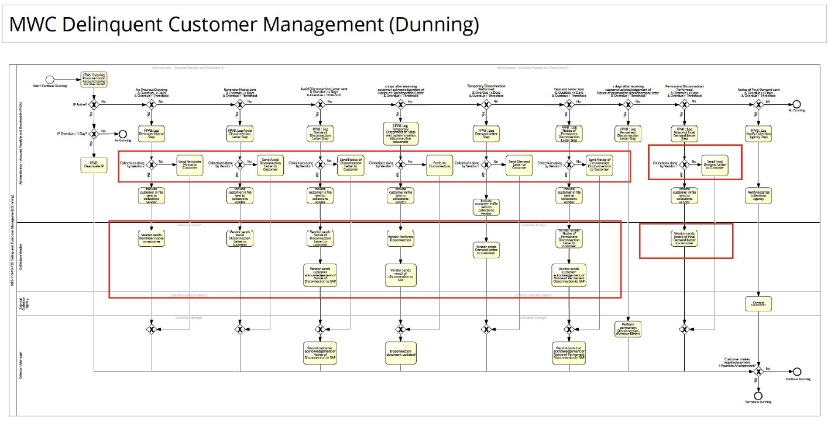

Authorization Requirements

Department /Roles within companies that will perform dunning activities must have Authorization to execute the custom t-code , access files in the application server and Upload files.

Dependencies / Constraints

- File format and its field mapping and acceptance logic from Service providers must be accepted and confirmed.
- Dunning Activity file must be received by the service provider /inhouse collections team and the activity mentioned in the file must be executed / attempted to be executed before executing this process.

Assumptions

- The file format is the same for all ISU companies.
- The dunning activity File created will be saved on path i.e. provided on batch schedule run.
- One dunning activity File will be sent by services providers or uploaded by inhouse collections team each day.
- If no dunning activities are performed on a given day, then the service providers / inhouse collection team will not send/upload any file.
- For processing of the file , the Interface program/T.code must always be executed in batch processing mode(background).
- Only one file per day will be received for each company code / service provider combination (In case the company performs the dunning activity in house then only one file per day will be uploaded.)
- The file will include results of Temporary Disconnection requests as well as acknowledgement of dunning letters/notices . Here are the collection steps /dunning activity codes that will be included in the file :
Action Taken | Type | Coding for External Service Providers
Reminder Letter | C001 | RTP
Avoid Disconnection Letter | C002 | ADL
Notice of Disconnection Letter | C003 | NOD
Notice of Disconnection Letter - II | C004 | NDL
Temporary Disconnection | C005 | TCD
Meter Pullout | C006 | TCD
Notice of Permanent Disconnection | C007 | PDL
Notice of Final Demand Letter | C008 | FDL
Demand Letter | C011 | DML

- For companies that use a service provider, the file will be sent by them via SFTP to SAP S/4 . For companies that perform activities in-house, the file will upload manually to SAP.

Dunning Letters :
SAP will only send the dunning activity file (described in FS DID_M2C_137) with detailed information and not send / print images/pdfs of the dunning letter itself.

The file format / mechanism that will be used for capturing acknowledgment of letters sent by service providers will also be used for capturing acknowledgment of dunning letters sent in house.

The same dunning activity file format will be used across all Service Providers and by BU’s that perform in house printing . The Service providers and BU’s that perform in house printing will have templates of the dunning letters – they will create letters with the information provided in the dunning activity file. While printing the letter, 2 hard copies of the letter are printed - One is sent to the customer , the other is retained by MWC for regulatory purposes.

Security Requirements

No encryption required for File.

System Details & Direction

- File Creation: SAP S/4 HANA
- Sending System: Service Providers / S/4 ( Inhouse )
- Receiving System: SAP CPI
- Direction: Inbound

Transaction Volume

Daily Volume is expected to be in range of 50K~ to 60K~

Average Download File Size : 250KB

Frequency & Timing

Interface is scheduled to run daily (all 7 days in a week).
Timing: As per batch run.

Initiating Process / Transaction / Program

Interface Program/ Tcode is executed as per the batch schedule or on demand( To view/ Upload the created file)

Processing Type
The program will operate in three modes :
- Process File mode : Executed in background as a batch job
- Upload File Mode : Executed in foreground on an ad-hoc real time basis
- View File Mode : Executed in foreground on an ad-hoc real time basis

Detailed description

Functional Requirement

A new custom program/T.code will be developed and will have three modes :
- Process File mode : The program will retrieve the files from S/4 HANA from a pre-determined application server folder , read the file and update SAP S/4
- Upload File mode : The program will allow a user to upload a dunning activity results file from their system to a pre-determined application server folder in S/4 HANA
- View File Mode : The user will be able to download the results activity file that have been processed from S/4 HANA
Create a new custom program (and transaction code) that will have the following input parameters:
Name | SAP Field Name | Data Type & Length | Type
Company Code | BUKRS | CHAR(4) | Mandatory – Single
Service Provider | Custom | CHAR(12) | Mandatory – Single
Processing Date | Custom | DATS(8) | Mandatory – Single
Mode | Custom | Radio button | - Process File Mode ( Default )  - View File Mode  - Upload File Mode
Select File | Custom | CHAR(255) | Mandatory – shown only if Upload File option was selected
Download Template | Custom | Button | Optional – shown only if Upload File option was selected
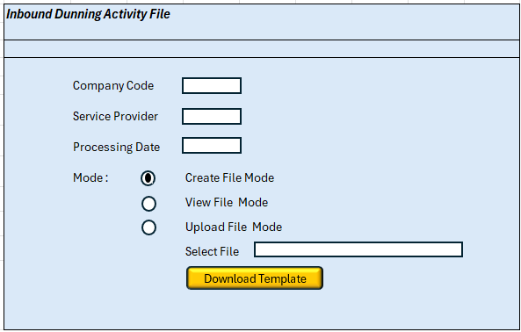
Processing Logic of the new custom program:

- Validate selection :
- Company code & Processing date must be provided . Only service providers maintained in the custom Dunning file path table (ZMWC_DUNPATH - Described in 2.a below ) can be selected
- Process File Mode - . Must be executed in background only. Display an information message on screen and return to selection screen if user attempts to execute in foreground.
- View File Mode & Upload File Mode -.Must be executed in foreground only via a T-code. Display an information message on screen and return to selection screen if user attempts to execute in background.
- Upload File Mode - The field “Select File” and “Download Template” must be displayed only if this mode was select . Else these two fields must not be shown. In case service provider value is not provided , then throw an information message.

- Logic for Process File Mode:
- Get File Path Details :
Check the new custom Dunning File Path table - ZMWC_DUNPATH ( described in FS DID_M2C_137) to check the Inbound path(s) for the given Company code & Service provider combination. If there is no record found or if there is no valid path found, then throw an error message “Valid File Path not defined for given input”.

- Retrieve all files present in the inbound file path for the selected company:
  - Look for files with the corresponding file format ( InDun_M<Last two digits of company code>_<Service Provider>_<YYMMDD>.xlsx )
  - In case there are files that are of a different file name / type in the folder – then show error message in the Job log “ Unknown File <filename> not processed “ .
- For each file retrieved read the data as per defined file structure and perform the following
  - Get the following fields from the file. If any of the following fields are missing or any of the validations fail, then include the record in the error file on application server path.
File Field | Field description | Validation
Date ID | Date of Creation of the record | Must be in DD-MM-YYYY
Run ID | Additional Identification Characteristic | Must not be blank
Dunning Type | Dunning activity Code | Must be one of the following values :  RTP - Reminder Letter  ADL - Avoid Disconnection Letter  NOD - Notice of Disconnection Letter  NDL - Notice of Disconnection Letter - II  TCD - Temporary Disconnection /Meter Pull Out  PDL - Notice of Permanent Disconnection  FDL - Notice of Final Demand Letter  DML - Demand Letter
CAN | Contract Account Number | Must have a record present in table FKKMAKO with vkont = CAN and LAUFD= DATE ID AND LAUFI= RUN ID
Contract | Contract Number | Must be present if dunning type = TCD
Job Generation Date | Date record was received | Must be in DD-MM-YYYY Format
Job Execution Date | Date activity was carried out | Must be in DD-MM-YYYY Format
Job Execution Time | Time activity was carried out | Must be in HH:MM:SS Format
Disconnection Reading | MR at the time of disconnection | Must be present if dunning type = TCD and code = C100
MRU | Meter Reading Unit | Must be present if dunning type = TCD
Sequence | Sequence Number | Must be present if dunning type = TCD
ManufSerial Number | Manufacturer Serial Number | Must be present if dunning type = TCD
CODE | Result of activity | Must be one of the following:  If Dunning type : TCD Then Code must be  C100 - DISCONNECTED  C02 - WITH FULL PAYMENT  C05 - OBSTRUCTED GATE VALVE  C07 - OBSTRUCTED METER  C06 - BROKEN GATE VALVE  C11 - SA ON HOLD  C03 - WITH PARTIAL PAYMENT  C13 - UNEXECUTED  C08 - DEFECTIVE METER  C10 - PULLED OUT METER FROM DISCONNECTION  C09 - FOUND TCD  C12 - METER NOT UPDATED  C04 - WITH OWNERS PADLOCK  Other all other Dunning Types:  N1 - RECEIVED  N2 - INSERTED IN GATE/MAILBOX  N3 - RPO  N4 - REFUSED TO RECEIVE DUE TO PAYMENT  N5 - VACANT  N6 - FTCD/PULLED OUT  N7 - DEMOLISHED  N8 - CANNOT LOCATE  N9 - NOT VISITED
  - Additional validations of the file:
    - All columns in the excel are mandatory to be present . In case columns are not filled , then program should create an error log in error file on application server path
    - The first row in the file represents the header
    - The end of file is represented by the first blank row

- If the file/record passed validations, then :
  - For each entry record in file , get its corresponding record in table FKKMAKO with vkont = CAN from file and LAUFD= DATE ID from file AND LAUFI= RUN ID from file and ZDunning Type from file
  - Update the following fields for the given FKKMAKO entry :
- JOB GENERATION DATE = SY-DATUM
- Job Execution Date - From File record
- Job Execution Time - From File record
- REFERENCE ID = Filename
- CODE – From File record
- LAST CHANGE DATE = SY-DATUM
- LAST CHANGED BY = SY-USER
Make sure no other field is updated and no new record is created/deleted while making the above update to FKKMAKO

  - If the dunning type in the record is TCD and FKKMAKO-STEP = C005 OR C006 then
    - Get the disconnection document number DISCNO from table FKKMAKT with LAUFI = FKKMAKO-LAUFI, LAUFD = FKKMAKO-LAUFD, GPART = FKKMAKO-GPART AND VKONT = FKKMAKO-VKONT.
    - Get the disconnection document entry from Custom z custom disconnection table - ZMWC_DISC - with DISCNO = Disc doc number and contract / MRU details retrieved above
    - Update the following custom fields for the given z custom disconnection table entry :
Field Name | Field Description
Disconnection Execution Date | Date activity was carried out
Disconnection Execution Time | Time activity was carried out
Disconnection Reading | MR at the time of disconnection
Disconnection locking Device Used | Locking Device used for disconnection
Disconnection Result Code | Result of the Disconnection
Kind Of Obstruction | Type of Obstruction during Disconnection
Disconnection Other Remarks | General Remarks
Disconnection Service Man | Name of service man

Make sure no other field is updated and no new record is created/deleted while making the above update to z custom disconnection table
  - For each file read, create an entry in a custom Dunning File Log table ZMWC_DUNFILE (as described in DID_M2C_137 ) to store details of files. The following fields must be updated during creation of the entry:
- Company Code – C.code for which the file is created
- Service Provider – Service Provider (if any) for which the file is created
- Processing Date – SY-DATUM
- Filename – Name of the file processed
- Outbound file – space
- Processed By -SY-USER
- No. of Records – Count of No. of records present in the file

- If the file was successfully processed , move the file to the archive folder - the path is maintained for the C.code /service provider in the Dunning File Path table - ZMWC_DUNPATH

- Logic for Upload File Mode:

If the “Upload File” button was selected by the user, then the program must allow a user to upload a dunning activity results file from their system to a pre-determined application server folder in S/4 HANA
The input fields “Select File” and “Download Template” must be displayed only if this mode was select . Else these two fields must not be shown.
- If the “Download Template” button was selected, then a template excel file (provided below ) must be created by the program and the user will have the option to download this file to their computer.
Template:
- Through the “Select File” field the user will be able to provide the path to a dunning activity results file which is stored on their computer. The program should throw an error message and return to the selection screen in case:
  - The file path is not provided or incorrect
  - The program is unable to read the file, or the file format is invalid
- After a MWC user inputs the file location ( on their computer ) and presses the execute button , the program should Get File Path & Filename format Details :Check the new custom Dunning File Path table - ZMWC_DUNPATH ( described in FS DID_M2C_137) to get the Inbound path(s) for the given Company code & Service provider combination . If there is no record found or if there is no valid path /filename found, then throw an error message “Valid File Path not defined for given input”. The filename provided as input must follow the filename convention .If not show error message “ Unknown File name / type - not processed “ .
- Show Pop up message : “Confirm upload of file <filename> to SAP? “ with two options – “Yes” or “Cancel”
  - If user Selects “Yes” , upload the selected file to the determined inbound file folder. After the upload is complete , show successfuly status message “File <filename> successfully uploaded to <filepath>”
  - If user Selects “Cancel” , show information status message “Processing Cancelled” and return to selection screen

- Logic for View File Mode:

If the “View File” button was selected by the user, then the program must retrieve the file(s) based on the selection criteria from the application server and allow the user to download the file.

After the user enters selection details and executes , do the following:

- Get File Details :
Get records from the new custom Dunning File log table - ZMWC_DUNFILE ( described in section above) for the given Company code & Service provider combination .
- If no record is found, then throw an error message “No Files created for given input”.

- Show File Details and Allow user to select File to be downloaded :
In the output screen show all retrieved files as follows:
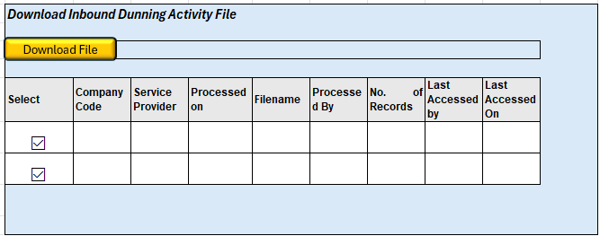
- The user will select the file to be downloaded by selecting the corresponding checkbox and pressing the “Download File” button
- In case the user does not select any checkbox or selects multiple checkboxes then the program should show warning message “Please select only one file to download”

- Retrieve File Details and Allow user to download File:
  - Get inbound / archive file path from the new custom Dunning File Path table - ZMWC_DUNPATH ( described in section above) to get the expected file name(s)/ path(s) for the given Company code & Service provider combination . If there is no record found or if there is no valid path found, then throw an error message “Valid File Path not defined for given input”.
- First check the file exists in the output folder , if not present then check the file exists in the archive file path
- If the file is found, then allow the user to download the file to their local system and update the following 2 fields in the corresponding file record in ZMWC_DUNFILE:
  - Last Accessed By – SY-USER
  - Last Accessed On – SY-DATUM
  - If the file is not found, then throw an error message “Selected file could not be found or is deleted”.
  - If the file could not be downloaded, then throw an error message “Selected file could not be downloaded”.

Interface Process Flow Diagram
For companies that use a service provider, the file will be sent by them to SPA S/4via SFTP .
For companies that perform activities in house, the file will be uploaded manually to SAP S/4 using the “Upload File” Option
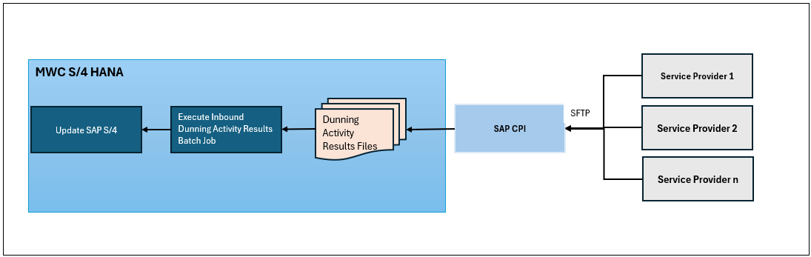

Proposed Transfer Method / Program

File created must be in ‘.XLSX’ format.

File Specifics

File Type: Excel . ( .xlsx)
File Format: See attached:

AL11(Application Server path): The files will be processed from the Inbound File Path by this interface. After processing the file will be moved to the archive folder :
Company Code | Service Provider | Inbound File Path | Inbound Archive File Path | Inbound Filename Format*
M001 | USI | <rootdir>/Inbound/Input/M2C/Dunning/M001/USI/ | <rootdir>/Inbound/Archive /M2C/Dunning/M001/USI/ | InDun_M01_USI_YYMMDD
M001 | NSCA | <rootdir>/Inbound/ Input //M2C/Dunning/M001/NSCA/ | <rootdir>/Inbound/Archive/M2C/Dunning/M001/NSCA/ | InDun_M01_NSCA_YYMMDD
M002 | INHOUSE | <rootdir>/Inbound/ Input /M2C/Dunning/M002/INHOUSE/ | <rootdir>/Inbound/Archive/M2C/Dunning/M002/INHOUSE/ | InDun_M02_INHOUSE_YYMMDD
M005 | INHOUSE | <rootdir>/Inbound/ Input //M2C/Dunning/M005/INHOUSE/ | <rootdir>/Inbound/Archive /M2C/Dunning/M005/INHOUSE/ | InDun_M05_INHOUSE_YYMMDD
M005 | PACER | <rootdir>/Inbound/ Input /M2C/Dunning/M005/PACER/ | <rootdir>/Inbound/Archive /M2C/Dunning/M005/PACER/ | InDun_M05_PACER_YYMMDD
M006 | TRACER | <rootdir>/Inbound/ Input /M2C/Dunning/M006/TRACER/ | <rootdir>/Inbound/Archive /M2C/Dunning/M006/TRACER/ | InDun_M06_TRACER_YYMMDD
M007 | INHOUSE | <rootdir>/Inbound/ Input //M2C/Dunning/M007/INHOUSE/ | <rootdir>/Inbound/Archive /M2C/Dunning/M007/INHOUSE/ | InDun_M07_INHOUSE_YYMMDD
M008 | INHOUSE | <rootdir>/Inbound/ Input /M2C/Dunning/M008/INHOUSE/ | <rootdir>/Inbound/Archive /M2C/Dunning/M008/INHOUSE/ | InDun_M08_INHOUSE_YYMMDD
M009 | INHOUSE | <rootdir>/Inbound/ Input /M2C/Dunning/M009/INHOUSE/ | <rootdir>/Inbound/Archive /M2C/Dunning/M009/INHOUSE/ | InDun_M09_INHOUSE_YYMMDD
M010 | INDRA | <rootdir>/Inbound/ Input /M2C/Dunning/M010/INDRA/ | <rootdir>/Inbound/Archive /M2C/Dunning/M010/INDRA/ | InDun_M10_INDRA_YYMMDD
M011 | INHOUSE | <rootdir>/Inbound/ Input /M2C/Dunning/M011/INHOUSE/ | <rootdir>/Inbound/Archive /M2C/Dunning/M011/INHOUSE/ | InDun_M11_INHOUSE_YYMMDD
M013 | BMIRK | <rootdir>/Inbound/ Input /M2C/Dunning/M013/BMIRK/ | <rootdir>/Inbound/Archive /M2C/Dunning/M013/BMIRK/ | InDun_M13_ BMIRK_YYMMDD
*YYMMDD – File creation date . Other values are static as shown above.

File naming convention:
InDun_ M<Last two digits of companycode>_<Service Provider>_<YYMMDD>.xlsx
E.g. InDun_M01_USI_251103.xlsx , InDun_ M02_INHOUSE_251224.xlsx

Sample Files:

Validation of Selection Criteria

Covered in Section 3.1 Processing Logic section

Variants
As per batch schedule – One variant per company code

Target / Source Data Layout

File Format: See Section 3.4

Mapping SAP Fields to Source / Target

Column # | Field Name | Field Description | SAP Field
1 | Creation Date | Date of Creation of the record | FKKMAKO-LAUFD
2 | Run ID | Additional Identification Characteristic | FKKMAKO-LAUFI
3 | Dunning Type | Dunning activity Code | FKKMAKO-ZDUNNING TYPE
4 | Service Area | Service Area | FKKMAKO-ZSERVICE AREA
5 | DMZ | Demand Monitoring Zone | EHAUISU-REGIOGROUP_PERM
6 | MRU | Meter Reading Unit | EABLG- ABLEINH
7 | Sequence | Account Sequence Number | ILOA- EQFNR
8 | ManufSerial Number | Manufacturer Serial Number | EQUI- SERGE
9 | CAN | Contract Account Number | FKKMAKO-VKONT
10 | Contract | Contract Number | FKKMAKO-VTREF
11 | Name | Name of the Customer | N/A
12 | Address | Address of the Customer | N/A
13 | Minimum Payment | Overdue Balance of the Customer | FKKMAKO-MSALM
14 | Total AR | Total AR of the Customer | FKKMAKO-ZTOTAL AR
15 | Due Date | Due Date of Notice | FKKMAKO-NOTICE DUE
16 | Job Generation Date | Date record was sent | FKKMAKO- ZJOB GENERATION DATE
17 | Job Execution Date | Date activity was carried out | FKKMAKO-ZJOB EXECUTION DATE
18 | Job Execution Time | Time activity was carried out | FKKMAKO-ZJOB EXECUTION TIME
19 | Disconnection Reading | MR at the time of disconnection | N/A
20 | Locking Device Used | Locking Device used for disconnection | N/A
21 | Code | Result of the activity | FKKMAKO-ZCODE
22 | Received By | Letter/ Notice received by | N/A
23 | Realtionship to the Owner | Receiver Relationship | N/A
24 | Kind Of Obstruction | Type of Obstruction | N/A
25 | Other Remarks | General Remarks | N/A
26 | Service Man | Name of service man | N/A

Transaction Screen Sequence
Process File mode – No screens after execution – background

Dependencies
- Job Dependencies: Files must be sent by service providers and placed in the appropriate application server folders
- Creation of relevant application server File Paths

Post Interface Activities
N/A

Source Data Archiving Requirements
- The inbound Files will be saved in the archive folder in the application server and will require periodic review

Network Integration
N/A

Reporting
N/A

Error Handling
- Errors encountered during batch processing must be logged in job/SLG1 logs.
- Errors encountered during the foreground processing must show messages as mentioned in in Section 3.1 Processing Logic section
- Errors during file transfer through SFTP will be handled by CPI exception handling

Security & Authorization

Department /Roles within companies that will perform dunning activities must have Authorization to execute the custom t-code , access files in the application server and upload files.

Reconciliation Procedures & Audit Requirements
N/A

Processing & Operational Considerations

Performance
Interface should be run for each company code in parallel jobs.

Batch Requirements

- Run Frequency: Daily
- Start Date: As per Batch schedule
- Start Time: As per Batch schedule
- Estimated Volume Per Run: 50k~ to 60k~
- Variant Required: Yes

Data Maintenance Requirements
- Custom tables will require periodic review for archival.

Re-Use Details
N/A

Multi-Company, Multi-Jurisdiction Considerations

Assumptions in Functional Design
- One dunning activity results File will be sent by services providers every day.
- If no dunning activity is processed on a given day, then no files will be sent / uploaded.
- For file processing . the Interface program/T.code must always be executed in batch processing mode(background).
- The interface batch job will be triggered prior to 11:59pm each day

Open Issues in Functional Design
- File format and its field mapping and acceptance logic from service providers must be provided and confirmed. .

Business Test Conditions

Scenario # | Input Selection Criteria | Expected Result
1 | Process results of accounts belonging to M001 with the following collection steps:  C001 Reminder Letter  C002 Avoid Disconnection Letter  C003 Notice of Disconnection Letter  C004 Notice of Disconnection Letter - II  C005 Temporary Disconnection  C006 Meter Pullout  C007 Notice of Permanent Disconnection  C008 Notice of Final Demand Letter  C011 Demand Letter  Execute Intbound dunning activity file Batch Job | All files that were sent by different service providers for M001 . were processed  The custom dunning log table and dunning header table and EDISCDOC table were updated correctly  The files were moved to the correct archive folder .
2 | No inbound dunning results file with wrong filename/ filetype stored in the inbound folder  Execute Inbound dunning activity file Batch Job | File must not be processed .
3 | No inbound dunning results file present in M001 inbound folder  Execute Inbound dunning activity file Batch Job | No action – no updates .
4 | User has Temporary Disconnection results file for accounts belonging to Ccode that performs activities in house .  Upload the file using the Inbound dunning activity custom T-code  Execute Inbound dunning activity file Batch Job to process the uploaded file | The file was uploaded successfully and processed  The custom dunning log table and dunning header table and EDISCDOC table were updated correctly  The processed files were moved to the correct archive folder .
5 | Download files created through the “View Files” mode in the custom t-code | User is able to view file details, select the file and then download the file to his/her local system .  The dunning log table is updated correctly ( last accessed by / on )
6 | Attempt to download files that are not yet created through the “View Files” mode in the custom t-code | System shows message: “Selected file could not be found or is deleted”.

Related Documentation
N/A

